Name: ____Zachary Baltrus____  
Date: _____1-30-2017________

1. What is good and bad about RAM as storage for the operating system and data? – 2pts

The only good thing about having RAM as storage for the operating system would be that it is so quick to access and the operating system would run very fast. However, as the reading from *Operating Systems Concepts Essentials* on page 10, the memory is too small to hold all of the files for an operating system. RAM is also volatile which means that once the system turns off, you cannot access the data on there anymore.

1. As you increase the number of processors by N, is the speedup ratio also N? Why or why not? – 2pts

Yes and no. The speedup ratio would increase but the ratio would not be consistent. You could find all of this using Amdahl’s Law which is a formula that identifies the potential performance gains.

1. What could you use a cluster for? – 1pt

A good use for a cluster would be two CPU’s on a server that would both be running applications and at the same time, checking each other’s status. This would be an example of symmetric clustering.

1. Where would you store a small amount of data, say a 32 bit integer – on the heap or stack? Why? – 1pt

You would sometimes want a small amount of data on the stack that you would only need to reference. Most of the info you would put on the stack would be things that you wouldn’t need later in the operating systems history so in theory this would save a lot of data.

1. Where would you store a large data structure (32MB+) on the heap or stack? Why? – 1pt

You would want to store this data structure on the heap for two main reasons. The first one would be that using the stack would only keep the data for a short period of time. Another reason would be that the heap is closer to the data.

1. Please fill in the blanks that describe the migration of integer A from disk to register (hint-pg 28): - 1pt

**Magnetic disk**

**C?**

**B?**

**A?**

A: __Main Memory_____

B: __Cache____________

C: __Registers__________

1. Please write an application (language of your choice but they MUST use system calls) that moves a file (ie implements mv command) in the platform of your choice (Windows or Linux).

Hint 1: I have an example of the cp command that uses system calls in C/C++ for Windows and Linux

Hint 2: unlink for Linux (<http://linux.die.net/man/2/unlink> ) and DeleteFile (<http://msdn.microsoft.com/en-us/library/windows/desktop/aa363915(v=vs.85).aspx> ) for Windows. – 3pts

1. Please write an API that wraps the code for the cp command such that the function has a prototype of: - 3pts

void cp(const char * src, const char * dst)

Hint 1: It’s simpler than you think

Hint 2: Look at the sample code

1. What benefits are there to a micro-kernel? What benefits are there to a monolithic kernel? Which would you use and why? -2pts

The benefits to using a microkernel is that they use minimal process and memory management. However, the main function of the microkernel is to communicate between the program and services running on the user’s space. One benefit I found for monolithic kernels in the book was that it could load and unload drivers at run time. I think I would use monolithic kernels just because they are used on Linux and it seems very cool with what you can do with them.

1. At what level ring/layer allows full unrestricted access to the hardware? – 1pt

A ring/layer 0, you would have unrestricted access to the hardware or reference memory.

1. Name 3 tools from either Windows or Linux that allow you to inspect system information and state what information they show. – 2pts

**Windows Disk Management -**  Used to format and change drives in windows. You can see all of the drives attached to the computer and what type of file system they are.

**Windows Device Manager –** Used to see all of the devices that are installed on your computer. Good way to find out if you have the correct drivers installed.

**Windows Power Shell –** It is a command line configuration framework that is open source and allows you full access to administration rights. It’s like CMD… but better… and in blue.

Extra credit:

1. In class we discussed two modern ways that people interact with the operating system (CLI/Shell and GUI). Today we interact with these interfaces, usually, with a keyboard and mouse. What other way(s) could one interact with the operating system? (Hint: It’s currently being researched/developed and Microsoft has their own concept(s):

<http://www.youtube.com/watch?v=a6cNdhOKwi0> ) – 2pts

Well, one way I can think of how we interact with our OS would be by touch. Another one that I think could be in the not so distant future would be brain signals interacting with the computer.

1. In the git repo I provide sample code from MikeOS (<http://mikeos.sourceforge.net/write-your-own-os.html> ). After you use the provided scripts to download the necessary tools to work with this code, the assignment is to see if you can add some color to the output. ie turn this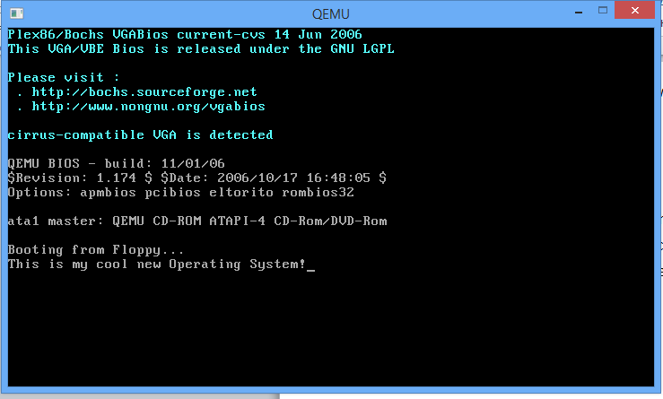  
   To this (be creative!): - 4pts 